Spotify APIs

# Postman Setup

1. Open New Tab > Authorization Tab > TYPE: OAuth 2.0
2. Click Get New Access Token
3. 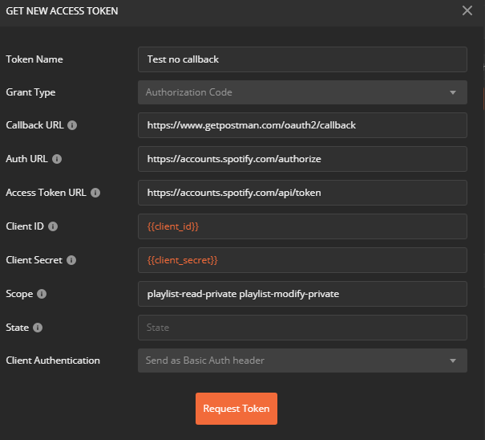
   1. Token Name: Spotify Token
   2. Grant Type: Authorization Code
   3. Callback URL: https://www.getpostman.com/oauth2/callback
   4. Auth URL: https://accounts.spotify.com/authorize
   5. Access Token URL: https://accounts.spotify.com/api/token
   6. Client ID: {{client_id}}
   7. Client Secret: {{client_secret}}
   8. Scope: playlist-read-private playlist-modify-private
   9. State: not sure about this yet
   10. Client Authentication: Send as Basic Auth header
4. Click Request Token
5. Copy **Access Token** from response and set environment variable:
   1. Authorization = paste access_token
6. Test API to get artist
   1. Headers:
      1. Accept:application/json
      2. Authorization2:Bearer {{authorization}}
7. Test API to Create Playlist
   1. Headers:
      1. Accept:application/json
      2. Authorization2:Bearer {{authorization}}
      3. Content-Type:application/json (not sure if this needed)
   2. Body:
      1. {
      2. "name": "Test2",
      3. "public": false
      4. }